Head of the Yarra (HOTY) guidelines re: Boat Storage and Racking, Trailer Parking and Race Day Road Closures.
- BOAT STORAGE & RACKING.

START LINE - Boathouse Drive, Melbourne
Boats may be stored in two locations near the city boat sheds on Boathouse Drive as shown below:
Peppercorn Lawn at the western end and Engineers Lawn to the southeast of Melbourne University Boat Club (MUBC).

Engineers Lawn is considerably bigger and most boats should be stored there.

Storage is allowed from 10:00 on Thursday 23 November onwards. After the regatta, all boats and trestles must be removed from Engineers Lawn and Peppercorn Lawn by 17:00 on Saturday 25 November at the latest.

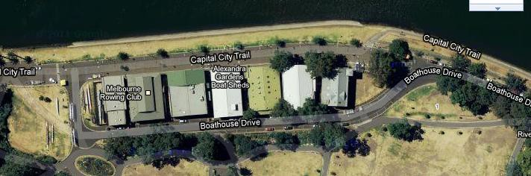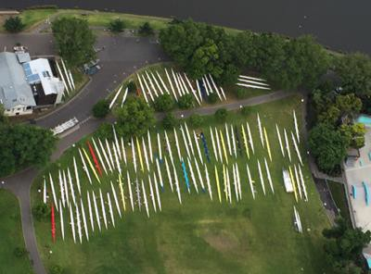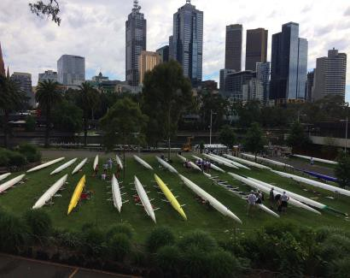Hawthorn Rowing Club, as hosts of HOTY implement security arrangements to minimise the risk of malicious damage caused by passer-bys, but competitors leave their boats at their own risk. Competitors will need to make own arrangements in relation to trestles. Please do not store boats overnight in front of the city rowing sheds. HOTY organisers will have a security guard patrolling the areas highlighted in green on Friday 24 November from 10am to Saturday 6am to protect your boats and oars.
PEPPERCORN
LAWN BOAT STORAGE
AREA
MUBC
ENGINEERS LAWN
BOAT STORAGE AREA
Security will patrol the area:
Friday 10am to Sat 6am

FINISH LINE -Yarra Bank Reserve, Hawthorn

Prior to Noon Friday 24th. Boats are to be stored in Yarra Bank Reserve on competitor-supplied trestles.

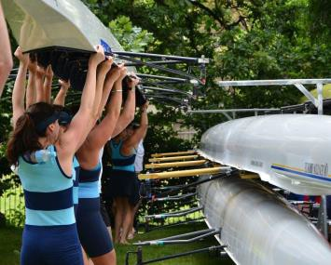
After 12pm Friday 24 November until 5pm Saturday 25 November.
Race Boat racks for all will be available for use within Yarra Bank Reserve.

Security will patrol the grounds of Yarra Bank Reserve at the following times:

Thursday - Friday - Saturday -
8pm to 6am Friday 8pm to 6am Saturday 6pm to 6am Sunday

TRAILER PARKING
Boats that remain over the Saturday night are asked to be placed on competitor- supplied trestles to facilitate boat rack removal. Hawthorn Rowing Club representatives will be required to move your boat if it remains on a boat rack in the clearing of the park post event.

START LINE- Boathouse Drive
In the start area, boat trailers can be parked on the roadway in parts of Boathouse Drive in the areas shown in yellow

Trailers can be parked as follows:
    - West of boatsheds (downstream): trailers can be parked on the hardstand roadway between the boatsheds and Princes Bridge. In this area, trailers can be parked on both the north and south sides but a clear gap of at least 4 metres must be left in the centre to provide access for pedestrians, cyclists and emergency vehicles.

    - Behind the boatsheds (central area): trailers can be parked on either side of Boathouse Drive behind the boatsheds. The road is narrow here, so please take care to ensure your trailer is hard up against the curb and a clear gap of at least 4 metres is left in the centre to provide access for pedestrians, cyclists and vehicles.

    - East of boatsheds (upstream): in this area trailers can be parked only on the north (river) side of Boathouse Drive. Please take care to ensure your trailer is hard up against the curb.

    - 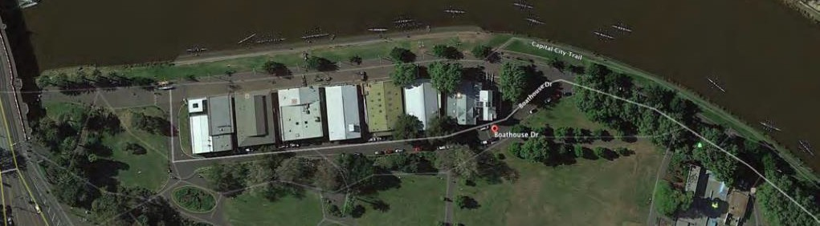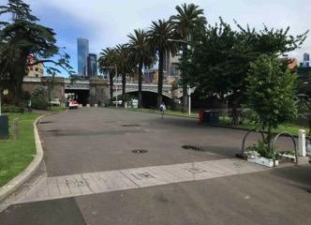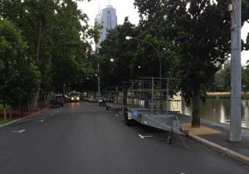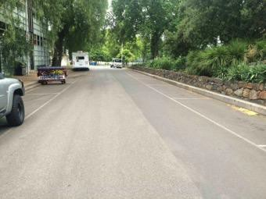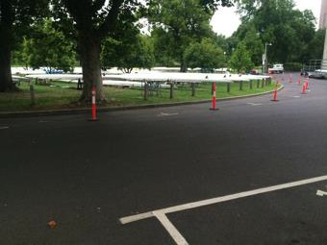Do not park a trailer or drive on any grassed area. This is not permitted in our permit from the Melbourne City Council and heavy fines will apply to the tow vehicle driver. Do not park a trailer in front of the boat sheds (as shown in red). Do not park a trailer on the south side of Boathouse Drive opposite Engineers Lawn (as shown in red)
South side
North side
Park trailers on north & south side with >4m pedestrian & emergency vehicle access through centre
Park trailers on Boathouse Dr opposite
Engineers Lawn on north (river) side only
Peppercorn Lawn
Engineers Lawn
Do not park trailers on south of Boathouse Drive
adjacent to Engineers Lawn
Park trailers on both sides of road behind boatsheds leaving >4m for access through centre

  - FINISH LINE – Hawthorn Residential Areas

As a residential area, the storage of boat trailers is limited to the yellow area in the image below along Creswick St and is only available to crews that have pre-booked trailers in this area. Parking on the EAST side of CRESWICK STREET will be prohibited in 2023 in order to maintain a wider access on the road way.

The activity of carrying boats across Church Street is prohibited at all times due to safety concerns in crossing a busy road with trams.

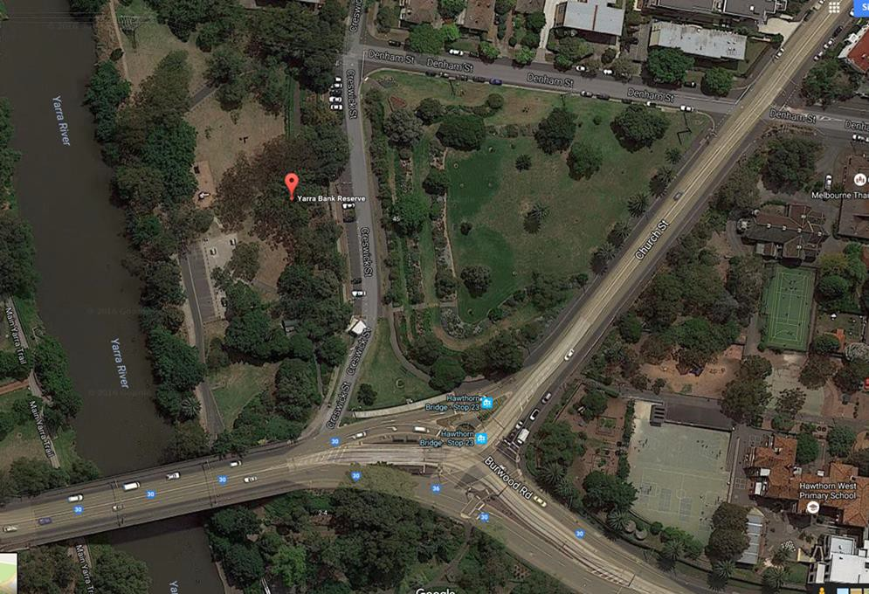
Finish
Area Activities and
Boat Storage
Creswick Reserve
No trailer parking
Only boats on trestles permitted in this park
NO
TRAILER ACCESS

Creswick Park Lower – NO TRAILER PARKING PERMITTED. Boat storage on trestles permitted only.

Pre-booked Boat Trailer Parking, ensure park efficiently on angle. Road closed during event. PROHIBITED PARKING AREA – East Side of Creswick Street.
Boats are NOT to be carried across Church Street
Pre-Booked Boat Trailers that park in this area of Creswick St throughout the weekend are requested to park on an angle in order to maximize the number of trailers without blocking through access along the Creswick Street.
Hawthorn Rowing Club reserve the right to move your trailer should a more efficient placement be possible.

Vehicles towing trailers must only enter Creswick Street from Bridge Road (must be travelling east and cross Bridge Road). Trailers can then be reversed into their parking positions.

Please note that council does not permit the parking of boat trailers on ANY grassed areas, particularly on Creswick Reserve, a highly regarded and manicured parkland and also along Denham Street.

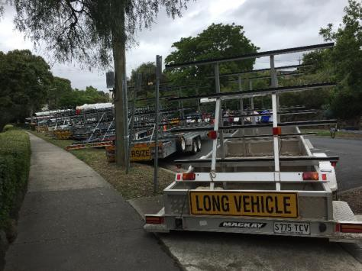
Pre-booked trailers parking in Creswick will reverse in on an angle on the west side of the street. On departure, vehicles and their trailers will exit by driving forward and turning right up Denham Street.

BESIDE THE COURSE TRAILER PARKING
There are ample Trailer Parking options along the course from Alexandra Avenue and Yarra Boulevard.
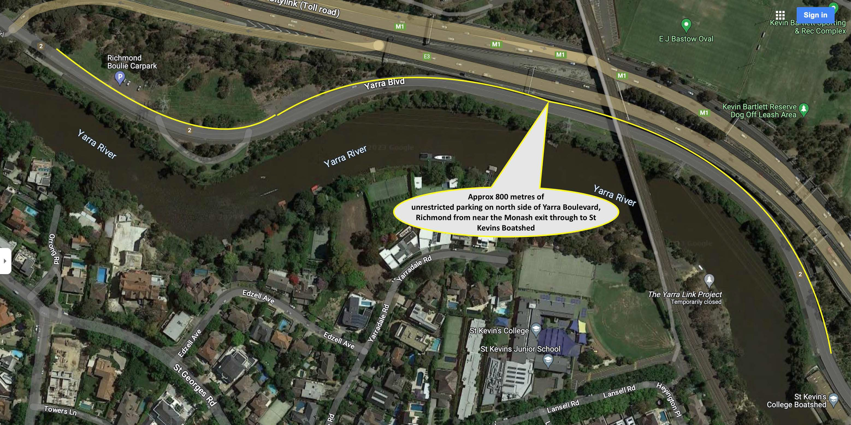
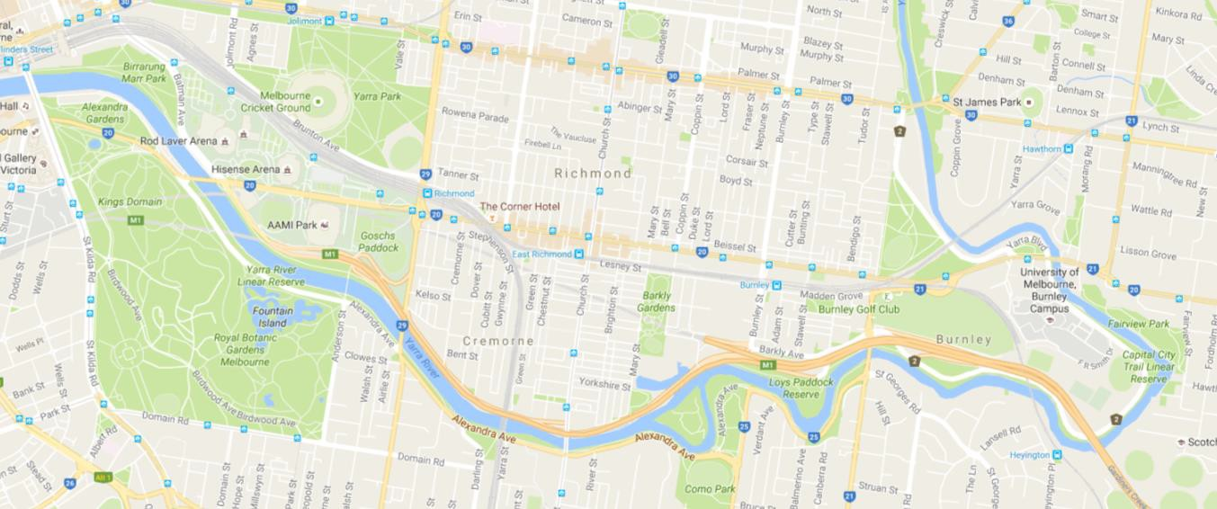Parking your trailer in these locations after dropping off your boats IS ENCOURAGED and makes shuttling back to city Hotels in your car easier. See map below for unrestricted parking location along Yarra Boulevard in Richmond.
Available Boat Landings with public access
F
Finish
S
5
Start
1.
2.
3.
4.
5.
Boathouse Drive, Melbourne
Wesley College Landing Powerhouse Rowing Club Landing St Kevin’s College Boat Landing Hawthorn Rowing Club Landing
(Note : Hawthorn inaccessible on race day)
2 3
4

RACE DAY ROAD CLOSURES

3.1 Start Area – Boathouse Drive Melbourne Saturday November 25
BOATHOUSE DRIVE, MELBOURNE will CLOSE on Saturday 25 NOVEMBER from 5am to 2.30pm, after which normal traffic conditions will apply.

Only boat trailers, Head of the Yarra official vehicles, delivery trucks and emergency vehicles will be permitted to enter the area. Please note that general vehicles will be turned away. This measure has been introduced to maintain pedestrian safety.
Boat Trailers will be able to remain within Boathouse Drive area during the road closure.

Finish Area – Creswick Street Hawthorn – Saturday November 25
Creswick Street between Denham Street and Bridge Road is closed on the day of the event from 9am and managed by a traffic management team to ensure the safety of pedestrians. Due to the congestion of competitors the road is completely closed during the event and NO vehicular access during this time will be possible unless pre-arranged. The activity of recycling of boats is NOT possible to access the area during this time by vehicle unless pre-approved. The road will reopen from 6pm.

Yarra Bank Reserve, Hawthorn
No vehicular access is possible to Yarra Bank Reserve, Hawthorn from Thursday 6am. On race day the road is used for official deliveries and emergency vehicles only. Should you arrive prior to the security guard being rostered it is imperative the trailer is moved on the Friday morning by 6am as the turning circle in the parking area is required for large vehicles with race infrastructure to exit the park. Any trailers remaining during this time will be removed by Hawthorn Rowing Club.

