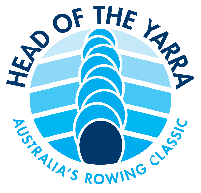 HEAD OF THE YARRA 2018
INTERNATIONAL ENTRY FORM

CLUB:

CLUB UNIFORM DESCRIPTION:

CLUB ADDRESS:

CONTACT PERSON:

CONTACT EMAIL:

CONTACT PHONE WHILE IN AUSTRALIA:

HEAD OF THE YARRA EVENT:

SEAT | FIRST NAME | SURNAME | DATE OF BIRTH | T-SHIRT SIZE
BOW:
2
3
4
5
6
7
STROKE:
COX:
COACH:
COACH:

PAYMENT DETAILS: on receipt of the International Entry Form, Rowing Victoria will send a link via email detailing payment through it’s merchant facility.

PLEASE RETURN THIS FORM TO:
laura@rowingvictoria.asn.au
by the close of entries – Sunday 4/11/2018 at 19:00 AEDT
The International Entry Form will be processed by Rowing Victoria, who will also organize payment of the entry fee.

